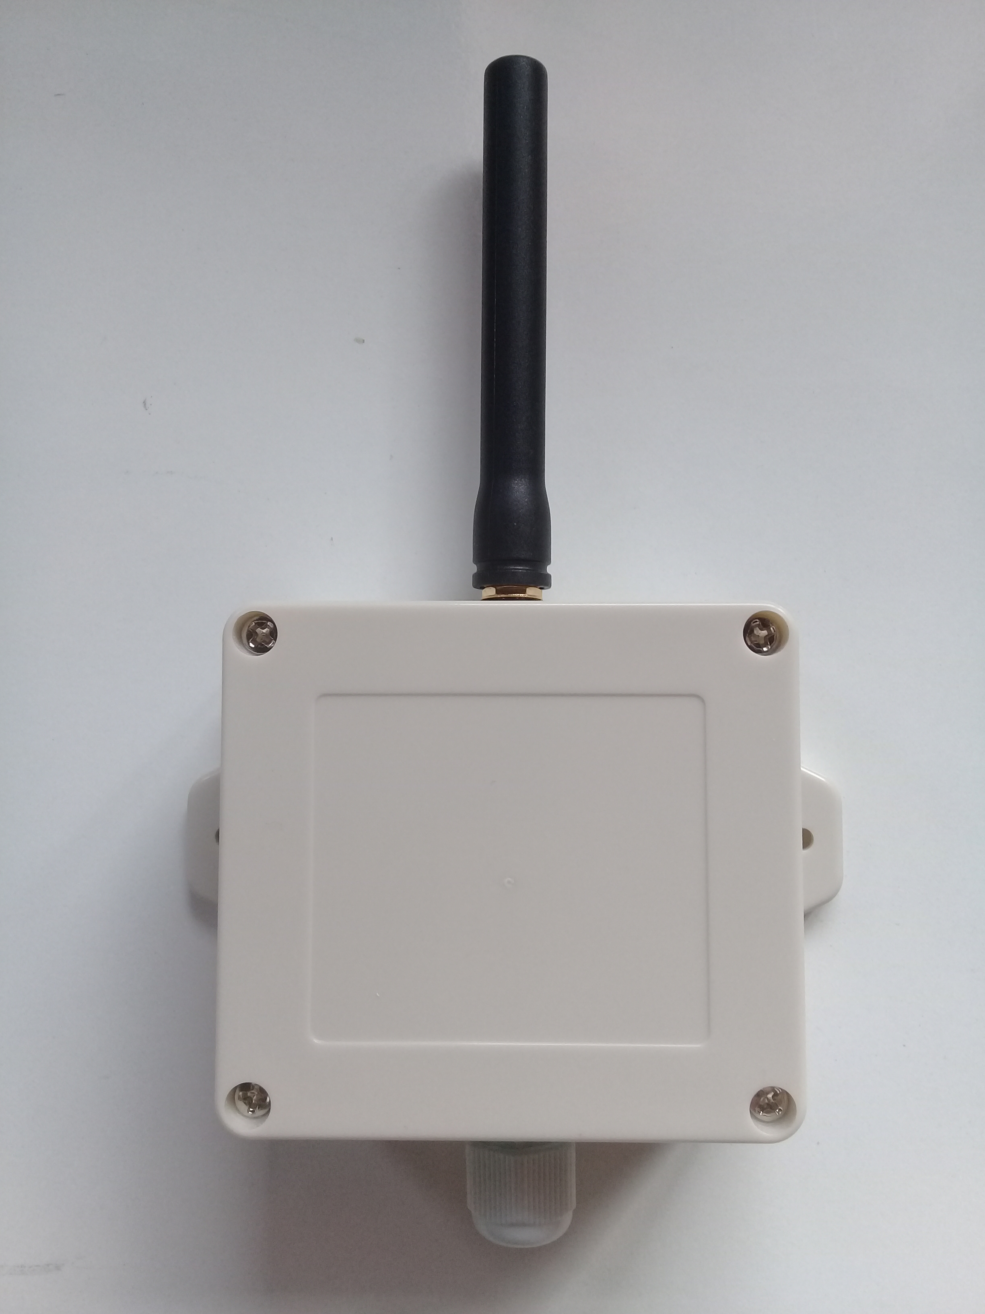

**LoRaWAN Outdoor Analog & Digital Sensor**

**SENSOR**

**Analog;**

2 independent input channels, Configurable Differential / Single

0-3V, 0-5V, 0-10V, 4-20ma, external sensor probes RTD, Thermocouple, Pressure

**Digital;**

2 digital inputs

Logic levels up to 10V, Dry Contact

Overvoltage and ESD protection

High and Low Alarms with hysteresis

**RADIO**

LoRaWAN Class A

Licence Free ISM Bands (EU868, US915..), Default EU868MHz, 8 Channel

Up to 100mW (20dbm) output power

High sensitivity -148dbm

3dbi External Antenna

Long Range, greater than 10km line of sight

**POWER**

3.6V 9000mah ER26500 C Size LiSClO2

15uA sleep current

Up to 10 years battery life depending on send interval

Low battery alarm

External power Input 5-12V, Managable output power 3-5V

**CONFIGURATION**

Configuration via USB, Pc, Phone, Tablet

Send Interval, 5min to 24h

High and Low Alarm thresholds

Full LoRaWAN parameters access

Over The Air Activation (OTAA) with DevEUI, AppEUI, AppKEY

**PHYSICAL**

Outdoor IP65 waterproof enclosure

Mounting flanges

76X70X40mm